DATA QUALITY

Data Quality Assessment Report
Tamar Tutisani

Contents
DATA QUALITY 1
Data Quality Assessment Report 1
Executive Summary 3
1 File Format Comparison: Parquet vs. CSV 3
2 Dataset Descriptions and Business Use 3
2.1 Bank dataset 3
2.2 car_prices dataset 3
3 Data Anomalies Found 4
3.1 Bank Dataset Issues 4
3.2 Car Prices Dataset Anomalies 7
Conclusion 11

Executive Summary
This report presents findings from a comprehensive data quality analysis of two datasets: bank.csv and car_prices (converted from parquet format). For this analysis, Excel was used to profile the bank.csv dataset, while SQL queries in PostgreSQL (DBeaver) were used to analyze the car_prices dataset to identify data anomalies. The bank dataset contains 4,521 customer records with 10 attributes, while the car prices dataset comprises vehicle sales records with 16 specification and transaction-related fields. Both datasets exhibit quality issues that require remediation before use in analytical or production systems. This report documents specific anomalies identified, their impact, and recommended actions.

File Format Comparison: Parquet vs. CSV
The car_prices dataset comes in two different formats with very different file sizes. The parquet file is 17.3 MB while the CSV file is 90.3 MB (shown in Figure 1), which means the CSV is about 5.2 times larger. The reason for this big difference comes down to how each format stores and compresses data.
Parquet is a columnar format, which means it groups data by column instead of by row. When data is organized this way, compression works much better because similar values are stored together. CSV on the other hand stores everything as plain text in rows, with no compression at all. This means every number, every text string, gets written out fully. For a dataset with 558,837 rows and 16 columns, this adds up really quickly. Parquet also stores numbers in an efficient binary format, so the number 2015 takes up much less space than the text characters "2015" in CSV. Parquet also has built-in compression that CSV just doesn't have. All of these things combined mean parquet can be about 5 times more efficient than CSV for this data
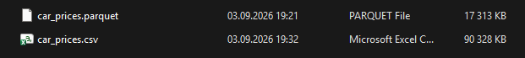
Figure 1. car_prices.parquet and car_prices.csv file size comparison

Dataset Descriptions and Business Use

Bank dataset
The bank.csv dataset contains 4,521 customer records from a bank's marketing campaign. The data includes basic customer information like age, job, marital status, and education level. It also has financial information like account balance, whether the customer has defaulted on credit, and if they have existing loans. The data also records details about a marketing campaign outreach, specifically what contact method was used (phone or cell) and how long the call lasted. This type of data is valuable for banking institutions in several ways: it enables customer segmentation and risk assessment, supports targeted marketing campaigns for financial products, helps identify default risk patterns, and can be used to optimize customer relationship management strategies. The data could also support predictive modeling for loan approval processes or campaign response rates.

car_prices dataset
The car_prices dataset has 558,837 records of used car auction sales with 16 different data fields. Each record includes vehicle details like the year it was made, the make and model, the trim level, body type, transmission type, and the vehicle condition rating. The data also includes sale information like who sold it, when it was sold, what price it sold for, and what the manufacturer's suggested value was. Other fields track the odometer reading, color, interior type, state where it was sold, and the vehicle's VIN (identification number). From a business perspective, this dataset is highly useful for used car dealers in pricing strategy development, for automotive market analysts tracking price trends over time periods, and for financial institutions assessing vehicle value for loan collateral purposes.

Data Anomalies Found

Bank Dataset Issues
Dataset: bank.csv
Anomaly 1: Age Values Out of Realistic Range
Attribute: age
Issue: The age column contains unrealistic values that fall outside the expected range of human ages. The minimum value found is negative 11 years, and the maximum reaches 200 years. Most critically, there are multiple entries with ages above 87 (including values like 122, 128, 130, 131, 132, 134, 140, 144, 150, 155, 160, 192, 200), which are extremely unlikely in banking customer data. (See Figure 2 for better understanding)
Example values: -11, 122, 128, 130, 140, 200
Detection method: Sorted the age column from smallest to largest and manually reviewed the outliers.
Assessment: These values appear to be data entry errors or corrupted records. Notably, nearly all records with ages above 87 share similar characteristics (predominantly "married" status and "no" default values), suggesting a systematic data corruption issue rather than random errors. Negative ages are impossible, and ages above 100 are statistically very rare and suspicious in banking contexts. These records should either be corrected if source data is available or removed as unreliable.
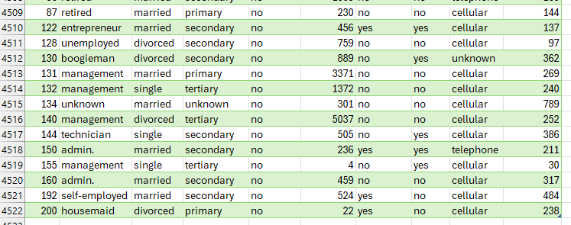
Figure 2. Unrealistic age outliers (122–200) in the bank.csv dataset
Anomaly 2: Invalid Job Category Values and Formatting Inconsistencies
Attribute: job
Issue: The job column contains multiple data quality problems. First, it contains the value "boogieman" which is not a legitimate occupation category. Other job values include valid categories like admin, technician, management, services, and retired, but "boogieman" does not fit any realistic job classification. Second, the valid job category "admin" is inconsistently formatted as "admin." (with a period) 478 times, while other job values do not use this punctuation format.
Examples: "boogieman" appears in records with suspicious age values (e.g., age 130, job boogieman); "admin." with period appears 478 times inconsistently
Detection method: Reviewed the list of unique values in the job column using Excel filter dropdown and counted occurrences.
Assessment: The "boogieman" value appears to be a data entry error or placeholder value that was not properly validated during data input. The inconsistent "admin." formatting suggests incomplete standardization during data processing. Both issues indicate that this column lacked proper validation rules during data collection or loading. All job values should be standardized to consistent formats and validated against an approved list of occupation categories. Invalid entries like "boogieman" should be reclassified or removed depending on data governance policies.
Anomaly 3: High Volume of Unknown Values in Job Category
Attribute: job
Issue: There are 38 records where the job field is listed as "unknown". While this is less severe than invalid entries, it represents missing information that limits customer segmentation capabilities.
Detection method: Filtered job column for "unknown" values and counted occurrences.
Assessment: These records lack critical business information. Depending on the data age, source data might be reviewed for recovery, or records may need to be handled separately in analysis.
Anomaly 4: Inconsistent Default Status Values
Attribute: default
Issue: The default column uses three different representations for values: "N", "no", and "yes" (shown in Figure 3). This inconsistency suggests incomplete standardization. The value "N" appears 15 times and should be standardized to either "yes" or "no" format.
Detection method: Reviewed unique values shown in the Excel filter dropdown for the default column.
Assessment: This is a data consistency issue that would cause problems in automated systems or analytics. All values should be standardized to a single format (likely "yes"/"no") before analysis or system integration.
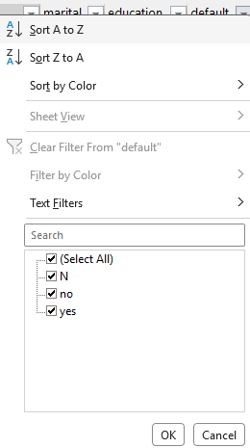
Figure 3. Values in the default column filter
Anomaly 5: Unexpected Negative and Zero Balance Values
Attribute: balance
Issue: The balance column contains 366 negative values and 357 zero values. While zero balance accounts are possible, the negative values are problematic. The minimum balance value is -3,313.
Detection method: Sorted balance column from smallest to largest and reviewed extremes.
Assessment: Negative balances may indicate overdrawn accounts or data errors. If these are legitimate overdraft situations, they should be flagged for review. If they are errors, they require correction. The high count of exact zero values also warrants investigation to determine if these represent closed accounts, data entry defaults, or actual zero balances.
Anomaly 6: Inconsistent Contact Method Representation
Attribute: contact
Issue: The contact column uses multiple representations for the same concepts: "unknown", "Unkn", and "NA" all represent missing or unknown contact methods. The standardized value "unknown" appears 1,312 times, "Unkn" appears 7 times, and "NA" appears 5 times. Valid values include "cellular" and "telephone" (shown in Figure 4).
Detection method: Examined the filter dropdown options and counted instances of each variant.
Assessment: This represents both a data consistency issue (multiple representations) and a data quality issue (1,329 out of 4,521 records have missing contact information). The different spellings of unknown values should be standardized, and the high proportion of missing contact data suggests either incomplete data collection or data loss during processing.
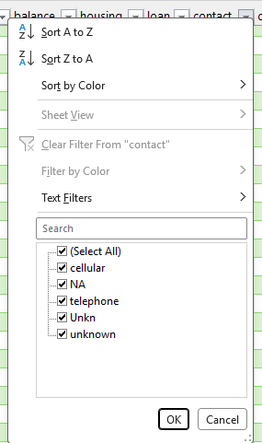
Figure 4. Values in the contact column filter
Anomaly 7: Negative Duration Values
Attribute: duration
Issue: The duration column contains 45 records with a value of -999, which is impossible. Duration represents call or interaction length and cannot be negative. The legitimate maximum duration is 3,025.
Detection method: Sorted duration column from smallest to largest and identified the negative value.
Assessment: The value negative 999 is commonly used as a missing data code or placeholder in some systems. These 45 records likely represent missing duration data that was improperly coded as negative 999 instead of being marked as NULL or a proper missing value indicator. These records should be marked as missing rather than containing an impossible negative value.

Car Prices Dataset Anomalies
Dataset: car_prices
Anomaly 1: Implausible Condition Values
Attribute: condition
Issue: The condition column ranges from 0.0 to 982.0, which is not meaningful for car condition data. Condition metrics typically range from 0-10 or 1-5. A value of 982.0 is nonsensical in this context (see Figure 5).
Detection method: Executed SQL query to find MIN and MAX values of the condition column.
Assessment: This suggests either incorrect data entry, a unit error, or corrupted records. The condition metric needs clarification on what scale is being used. Values above 10 or the defined maximum should be investigated and either corrected or removed.
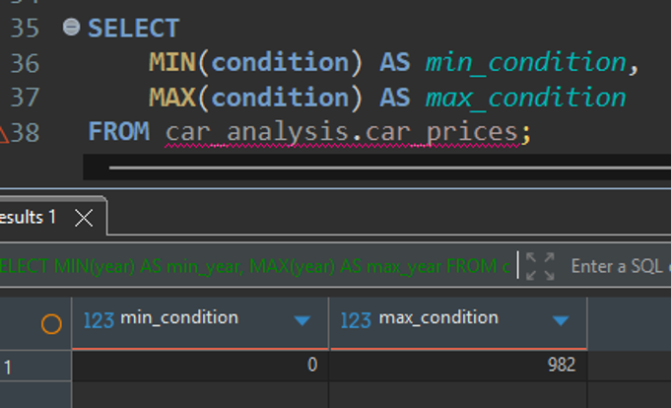
Figure 5. SQL query and results showing the min_condition and max_ condition for the dataset
Anomaly 2: Invalid and Missing Odometer Readings
Attribute: odometer
Issue: The odometer column contains significant data quality issues. There are 246 records with missing (NULL) or impossible values (see Figure 6). Additionally, there are 152 records with an odometer reading of exactly 0 and a concerning 1,318 records with an odometer reading of exactly 1 (see Figure 7). These exact values are highly suspicious and unlikely to be legitimate.
Detection method: SQL queries checking for NULL values, values equal to 0, and values equal to 1.
Assessment: Odometer readings of 0 and 1 are implausible for used vehicles, as virtually all vehicles have some mileage by the time they are sold. These exact values appear to be placeholder values or data entry defaults rather than genuine mileage readings. Combined with the 246 NULL or negative records, approximately 1,716 records lack reliable odometer information. This is critical for vehicle valuation, as mileage is one of the primary factors in pricing. These records should either be excluded from analysis or flagged for special handling and investigation into their data source.
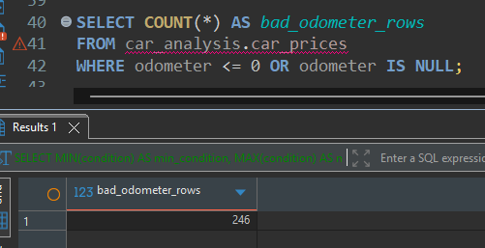
Figure 6. SQL query and result counting missing (NULL) or negative odometer values
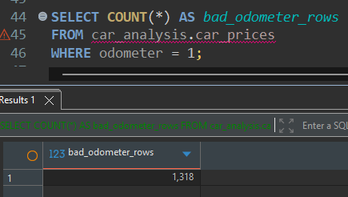
Figure 7. SQL query and result counting an odometer reading of exactly 1
Anomaly 3: Extensive Missing Values in Vehicle Specification Columns
Attribute: Multiple (make, model, trim, transmission, color)
Issue: Several critical specification columns contain significant missing data:
make: 10,301 missing values
model: 10,399 missing values
trim: 10,715 missing values
transmission: 65,321 missing values
color: 749 missing values
Detection method: SQL query checking for NULL or empty string values in each column (see Figure 8).
Assessment: The high number of missing values in transmission (65,321) is particularly concerning, suggesting either systematic data collection failures or data loss. Make and model information is essential for vehicle identification and pricing, so their absence is problematic. These missing values significantly limit the dataset's usability for detailed vehicle analysis and pricing models. The root cause of these missing values should be investigated.
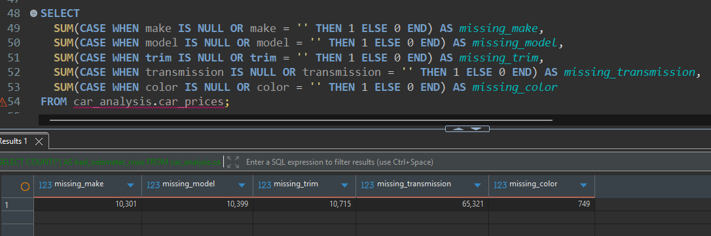
Figure 8. SQL query and results counting missing or empty values across the vehicle specification columns
Anomaly 4: Duplicate VIN Numbers
Attribute: vin
Issue: Multiple VIN (Vehicle Identification Number) values appear more than once in the dataset, which is suspicious. The value "automatic" appears 22 times (clearly not a VIN), and legitimate VINs appear multiple times with 5 to 3 occurrences each. Examples include "wbanv13588cz57827" appearing 5 times and multiple VINs appearing 3 to 4 times.
Detection method: SQL query grouping by VIN and counting occurrences, filtering for counts greater than 1 (see Figure 9).
Assessment: VINs should be unique identifiers for individual vehicles. Duplicates suggest either the same vehicle being listed multiple times (duplicate records) or data quality issues. The presence of "automatic" as a VIN value indicates data entry errors or misalignment where values from the transmission column may have been entered into the VIN field. These duplicates should be deduplicated, and the "automatic" entries need to be corrected or removed.
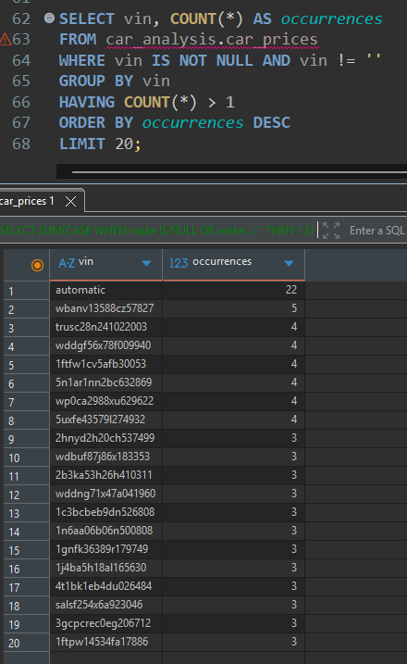
Figure 9. SQL query and results showing duplicate VIN entries
Anomaly 5: Vehicle Model Year Range
Attribute: year
Issue: The dataset contains vehicles ranging from 1982 to 2015 (33 year span). While this alone is not necessarily problematic, it should be verified that this range is intentional and appropriate for the analysis purpose.
Detection method: SQL query to find MIN and MAX year values (see Figure 10).
Assessment: This range is reasonable for a used car dataset, though the reason for the specific cutoff at 2015 should be verified. Ensure that any analysis accounts for the age of vehicles, as a 1982 vehicle and a 2015 vehicle are fundamentally different assets. This is important context for pricing and condition analysis.
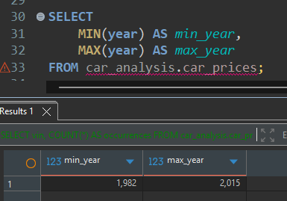
Figure 10. SQL query and results showing the minimum and maximum vehicle model years

Conclusion
The analysis of both datasets has revealed multiple data quality issues that require attention before these datasets can be reliably used for analytics, modeling, or business decision-making. The bank dataset exhibits problems with implausible values (negative and extremely high ages), invalid job categories, inconsistent value representations, and missing data patterns. The car prices dataset shows similar concerns with missing specification data, suspicious placeholder values in the odometer field, and duplicate records indicated by repeated VINs.
Before proceeding with any analysis, I recommend establishing a data validation and cleansing workflow. This should include removing or correcting records with clearly impossible values, standardizing all categorical fields to consistent formats, investigating the root causes of the high volume of missing values, and deduplicating records where appropriate.
These datasets can still provide value for business purposes, but only after systematic data quality improvements are implemented. The specific anomalies documented in this report should be addressed according to organizational data governance policies and business requirements.

